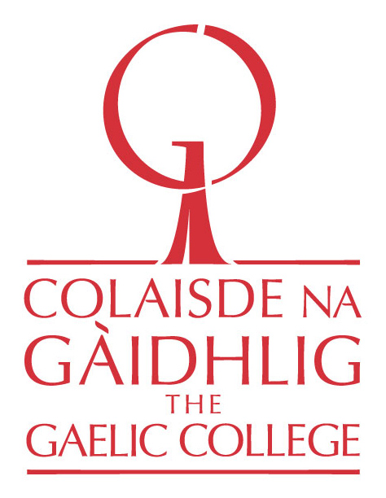

Na Gaisgich Òga | The Young Heroes Program 2020 - 2021
Am Foirm-iarrtais |Application Form
Name of Applicant
Gender
Date of Birth
Civic Address
Which community is closest to you in proximity? | [Halifax, Antigonish, Mabou, Iona, St. Ann’s, or Sydney]
Name of Parent or Guardian

Phone Number: Parent/Guardian

Email Address:
Parent/Guardian

Questions for the Applicant (Parents and Guardians are asked to assist if necessary)
- Provide a short description of your involvement to date with the Gaelic language and culture. Include any classes and programs you have participated in?
2. What inspired you to learn the Gaelic langauge?
3. What aspects of Gaelic culture are you interested in? (Storytelling, Song, Music, Dance, History, etc.)
4. What ways has your family and community helped you to learn about Gaelic culture?
5. Do you currently attend a public school in Nova Scotia that offers Gaelic programming? If so, are you enrolled in Gaelic classes?
6. Applicants must provide one reference person who can speak to their involvement in Gaelic language and cultural activities. Please include the individuals name and phone number here, and let them know that they may receive a call from us.
7. Applicants must also provide a video or audio recording (approximately two minutes long), where they introduce themselves in Gaelic/English and share Gaelic phrases and words they know. Appllicants may then switch to English, and describe why they wish to be in the program. Videos and recordings can be submitted to Colin MacDonald via email, colin@gaeliccollege.edu, or sent to The Gaelic College in a private message via Facebook Messenger. If you have already completed the program, a recording is not required.

Parents and Guardians:
I certify to the best of my knowledge that the information provided in this Youth Application is true and accurate. I give my informed consent and permission for my child to participate in “Na Gaisgich Òga” and its related activities, and will ensure he/she attends all sessions and mentoring visits.
Parent/Guardian Name
Date
Parent/Guardian Signature

Applications must be emailed to:
Colin MacDonald
Gaelic Director
Colaisde na Gàidhlig | The Gaelic College
Phone: 1-902-295-3411
colin@gaeliccollege.edu

