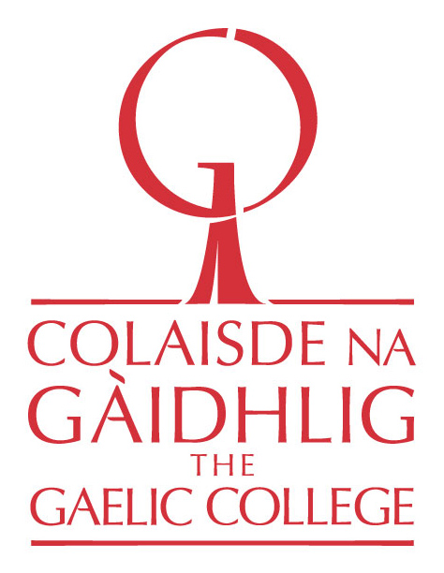

An Cùrsa Bogaidh II & III
Four-week Intensive Immersion Courses
Am Foirm-iarrtais |Application Form
Ainm
Name

Gnè
Gender

Là-breith
Date of Birth

Seòladh
Address

Post-dealain
Email

Àireamh Fón
Phone Number

Ìre  Level | Please state which course you are applying for, Intermediate or Higher Intermediate. ________________________________ .  An Cùrsa Bogaidh II (Intermediate): Applicant must have completed 6 credits of Scottish Gaelic language or the equivalent.  An Cùrsa Bogaidh III (Higher Intermediate): Applicant must have completed 12 credits of Scottish Gaelic or the equivalent.  Note: These courses are appropriate for personal development also.
Creideas  Credit | Do you seek university credit?
Oilthigh  University | If so, which university do you currently attend?
Please answer the following in English, Scottish Gaelic, or a mixture of both. If you choose to write in Gaelic, please include an English translation.
- Provide a brief description of your involvement to date with the Gaelic language and culture. Include a timeline of classes and programs you have participated in, and the names of any Gaelic instructors and mentors you have had.
2. Have you ever taken part in a Gaelic immersion class or program? If so, what was the length of the class or program and what teaching methodology was used?
3. How comfortable are you conversing in Scottish Gaelic?
4. How comfortable are you with reading and writing in Scottish Gaelic?
5. Do you have anything else you wish to add?
6. Please submit your completed application via email to Gaelic Director, Colin MacDonald (see below).

Once your application is received, Colin MacDonald will be in touch with you to schedule a phone interview prior to your acceptance. The interview will consist of a brief Gaelic conversation that focuses on basic phrases/subjects (e.g. how are you?, what’s new?, where are you from? the weather, etc.), followed by a conversation in English. The purpose of the interview is to help us gage students’ conversational abilities and to establish a connection with students prior to An Cùrsa Bogaidh.

Deadline: January 31st, 2020

Applications must be emailed to:

Colin MacDonald
Gaelic Director
Colaisde na Gàidhlig | The Gaelic College
Phone: 1-902-295-3411
colin@gaeliccollege.edu

