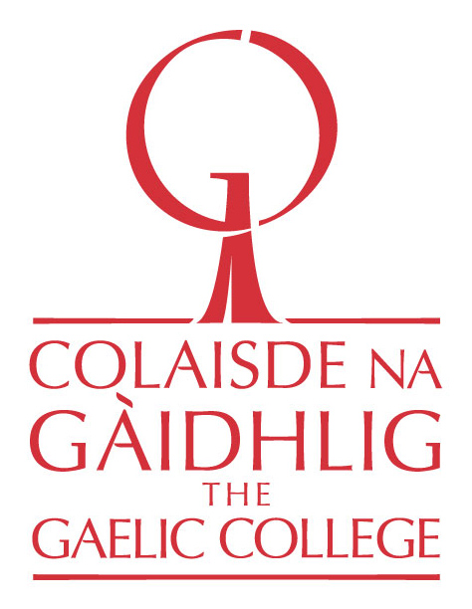

Na Gaisgich Òga | The Young Heroes Program 2019 - 2020
Am Foirm-iarrtais |Application Form
Name of Applicant
Gender (M/F/Other)
Date of Birth
Mailing Address
Street Address
Email
Phone
What school do you attend?
Are you a resident of Nova Scotia?
Parent/Guardian Name
Parent/Guardian Phone
Parent/Guardian Email Address
Applicants must provide one reference person (not a relative) who can speak to their involvement in Gaelic language and cultural activities. Our selection committee will be contacting this person.
Reference Person

Reference Person Phone Number &
Email Address
Questions for the Applicant Youth are asked to fill in this application with the assistance of their parents or guardians.
- Provide a short description of your involvement to date with the Gaelic language and culture. Include any classes and programs you have participated in, or other ways you’ve been exposed to the culture.
2. What do you think is important and special about the Gaelic?
3. How do you plan to pass on the Gaelic language and culture to others?
4. How has your family and community helped you to learn Gaelic or exposed you to Gaelic culture?
5. Do you currently attend a public school in Nova Scotia that offers Gaelic programming? If yes, are you enrolled in Gaelic classes?
6. If accepted, how do you plan to continue with language and cultural learning between our weekend sessions?
7. What do you like to do in your free time? For example: sports and physical activities, computers/media, video games, music, social activities, dance, arts & crafts, etc.
8. Applicants must also provide a short video or audio recording (approximately two minutes long), where they introduce themselves in Gaelic and share some Gaelic phrases / words they know. Appllicants may then describe in English (or Gaelic), why they wish to be in the program.

Videos and recordings can be submitted to Colin MacDonald via email, colin@gaeliccollege.edu, or via Messenger – search Colaisde na Gàidhlig | The Gaelic College on Facebook and send it in a private message.

If you have any questions regarding the application process or require technical assistance please contact Colin: colin@gaeliccollege.edu or 1-902-295-3411

Parents and Guardians:
I certify to the best of my knowledge that the information provided in this Youth Application is true and accurate. I give my informed consent and permission for my child to participate in “Na Gaisgich Òga” and its related activities, and will ensure he/she attends all weekend sessions and mentoring visits.
Parent/Guardian Name
Date
Parent/Guardian Signature

Deadline: August 30, 2019

Applications must be emailed to:

Colin MacDonald
Gaelic Director
Colaisde na Gàidhlig | The Gaelic College
Phone: 1-902-295-3411
colin@gaeliccollege.edu

